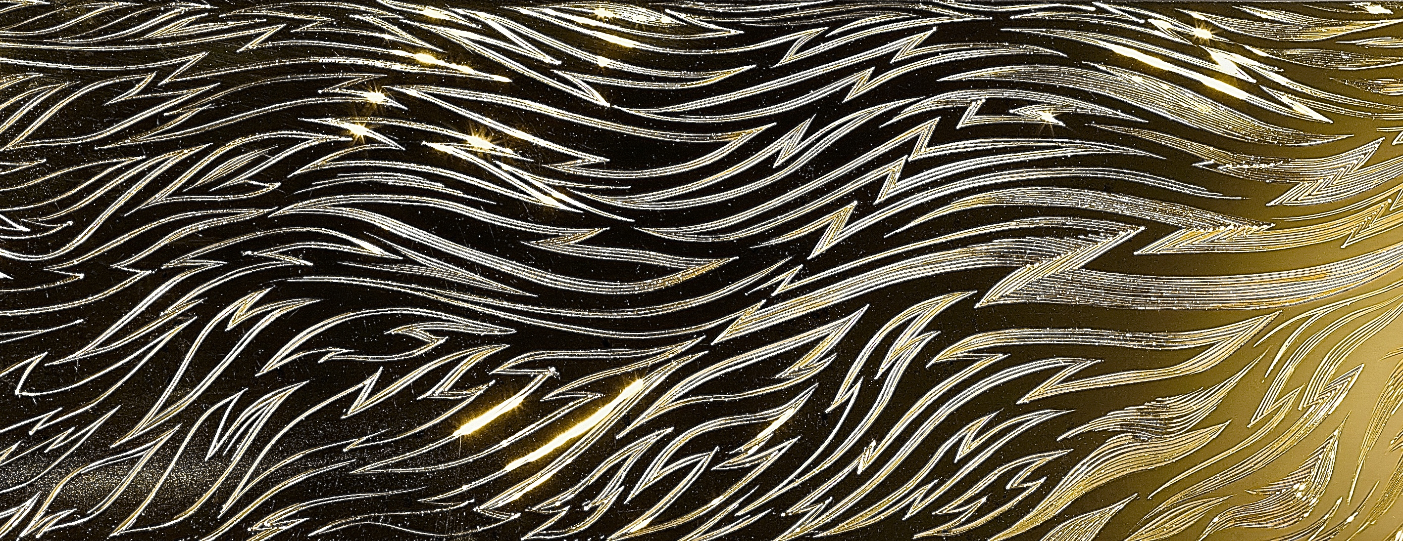
photo Simon B Armitt : engraved detail of SOL & LUNA Vases

C A A
Contemporary Applied Arts
A L A N C R A X F O R D A T 70
Exhibition runs from 25th January to 25 February 2017
10.00 till 6.00 Monday to Saturday

YOU ARE INVITED TO A SOIREE TO
VIEW & DISCUSS THE WORK IN COMPANY WITH ALAN.

Wine and nibbles served from -
5-7pm Wednesday 22 February 2017
89 Southwark Street, London. SE1 0HX

